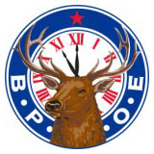 2026 Elks – Rox Alumni Dinner 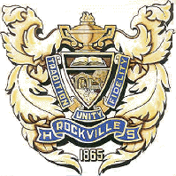
Saturday, September 26, 2026
Rockville Elks Lodge - 360 Strawberry Rd., Rockville, Indiana 47872
This year’s Annual Rox Alumni Dinner is scheduled for Saturday evening, September 26th beginning at 6:30 p.m. Anyone who would enjoy a few drinks before the meal is welcome to arrive earlier.
There are four options for dinner with pricing as follows: 12 oz. Ribeye dinner - $25.00, Pork Chop dinner - $18.00, Chicken Breast dinner - $16.00, Vegetarian dinner - $13.00
The Elks sponsor numerous charitable projects both locally and nationally each year and proceeds from this dinner is yet to be determined.
We need your help in preparing. If you would like to attend, please mark your dinner preference(s) and number attending below on this registration form and return it NO LATER THAN SEPTEMBER 19TH with your check payable to Rockville Elks Lodge.
Thank you,
JP Lucas
John.Lucas2947@gmail.com
We hope to see many of you there!
----------------------------------------------------------------------------------------------------------------

Name: __________________________ Phone: ___________________

Qty Amount
12 oz. Ribeye dinner $25.00 ____ $_______
Pork Chop dinner $18.00 ____ $_______
Chicken Breast dinner $16.00 ____ $_______
Vegetarian dinner $13.00 ____ $_______

TOTAL $_______

Mail to: Rockville Elks Lodge
360 Strawberry Rd.
Rockville, IN 47872

